Config your PCOM 1
Shutdown the system 5
Start the system 6
User ID and password: 15

Config your PCOM
Set IP and port:
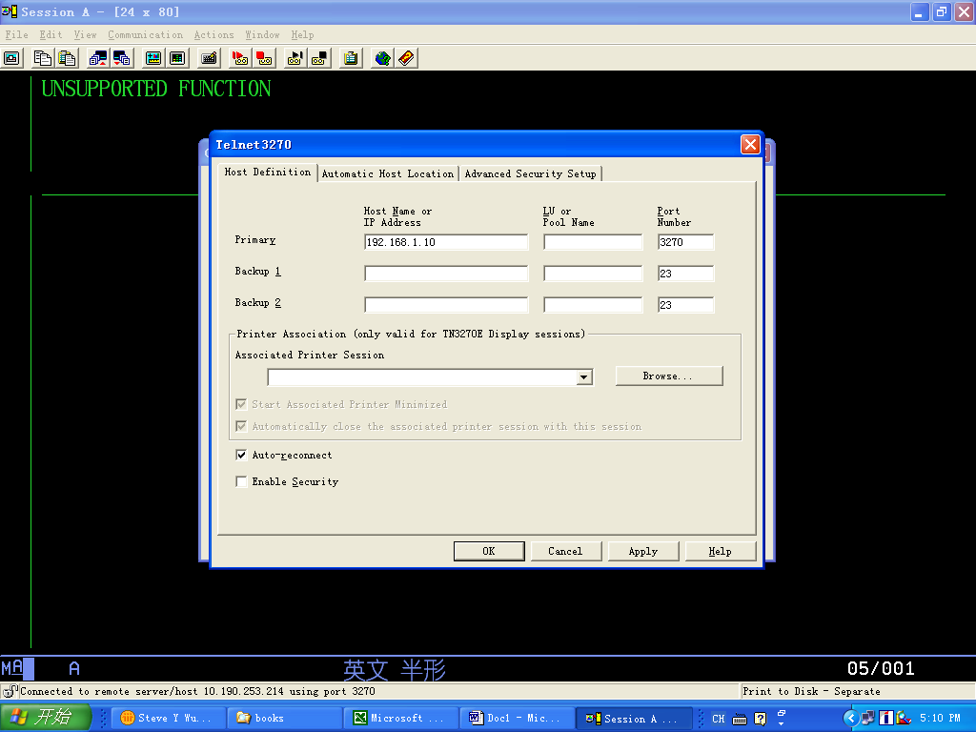
Set print:
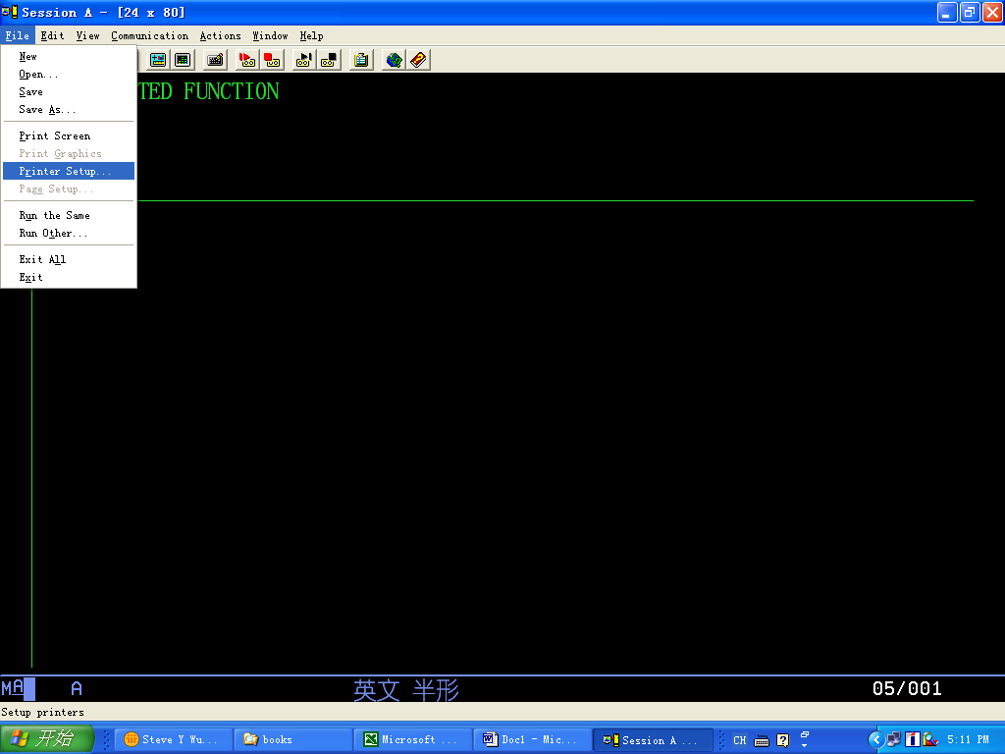
Choose ‘Print to disk – Append’ and Select PDT:
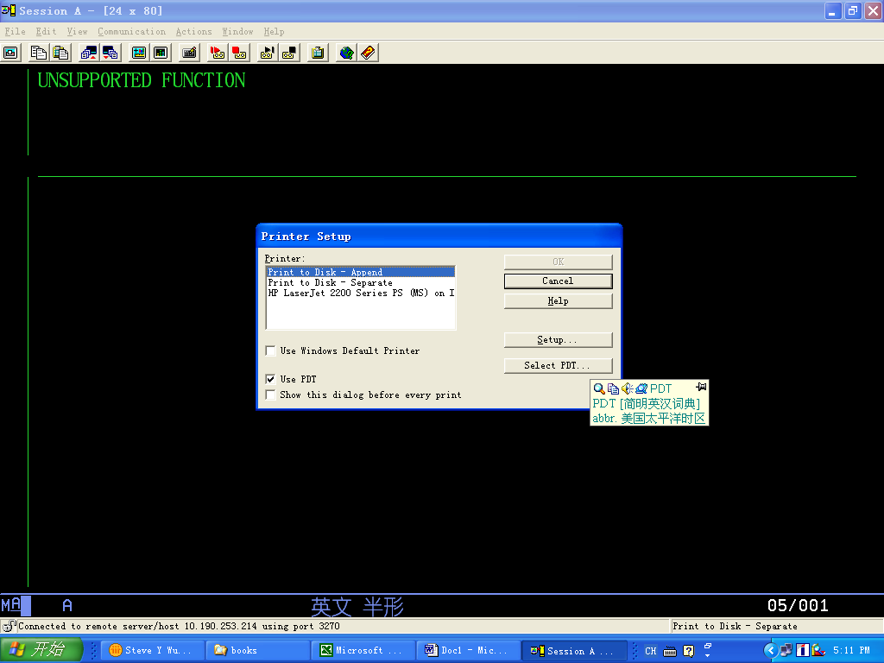
Select anyone and OK:
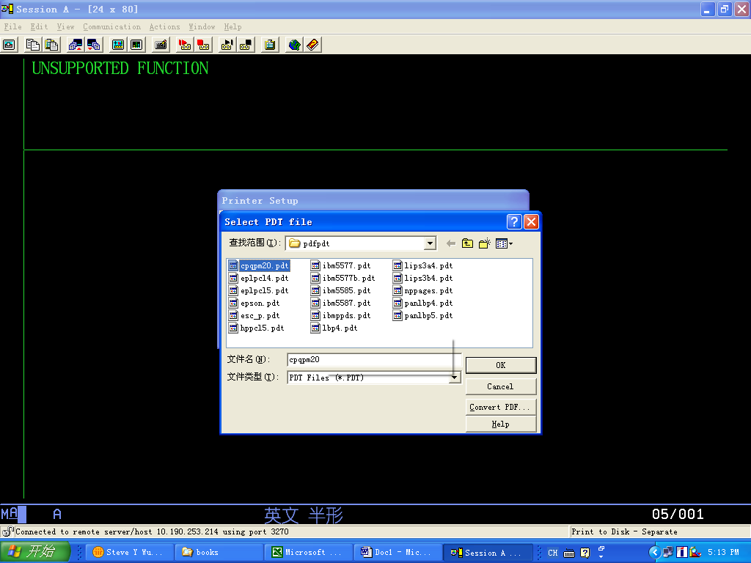
Hit ‘Setup’ and set a file name as below:
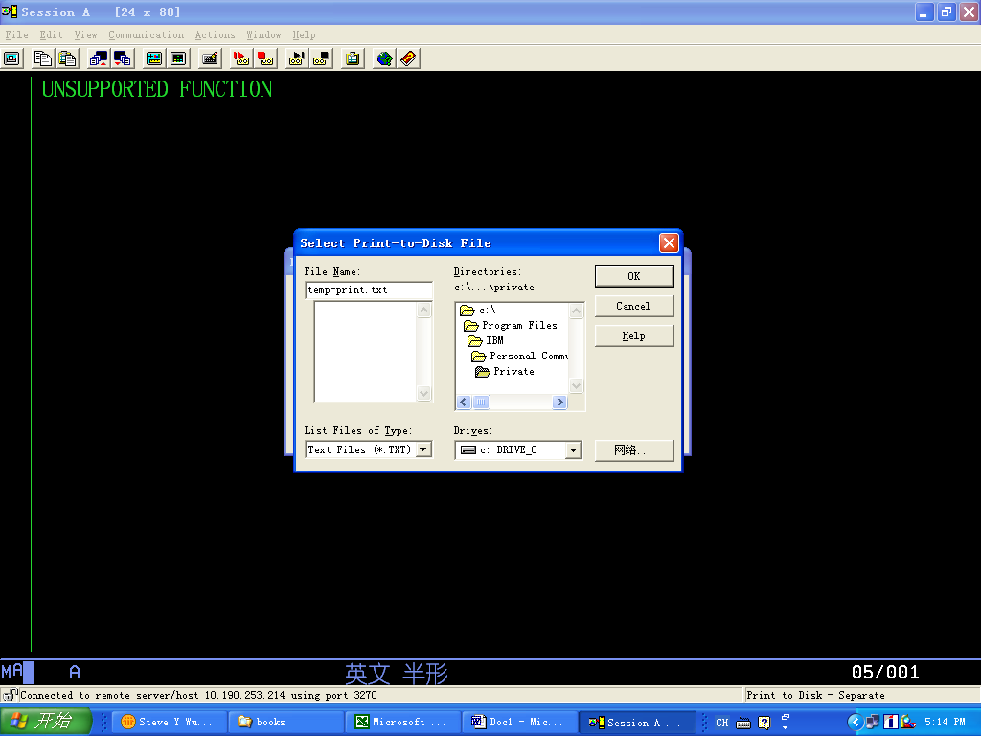
Choose OK:
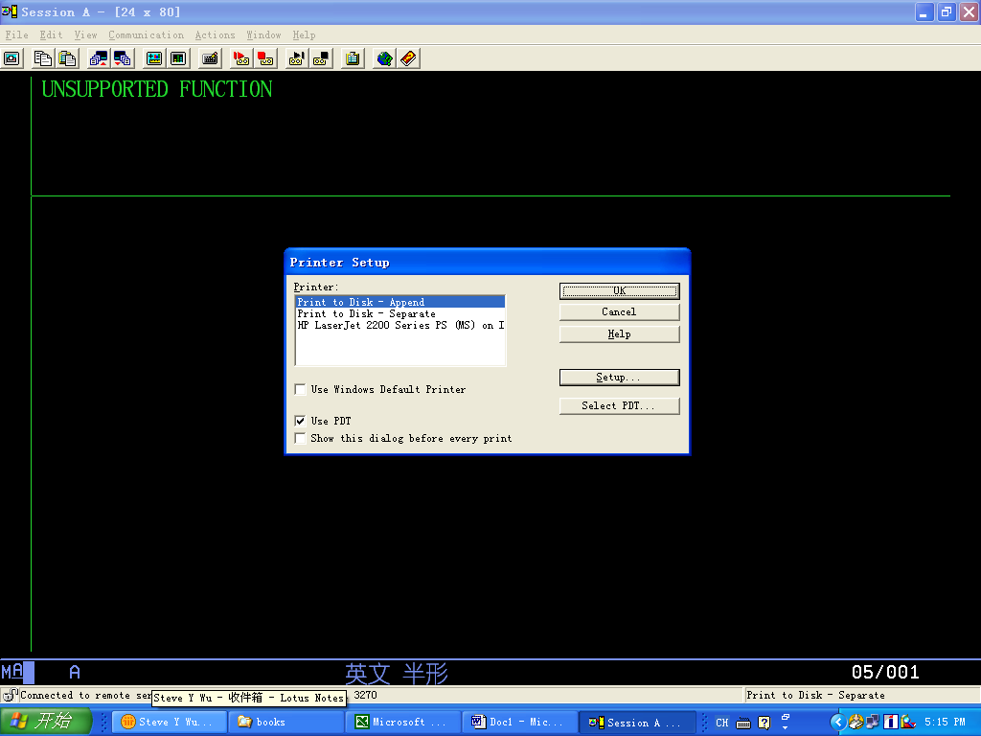
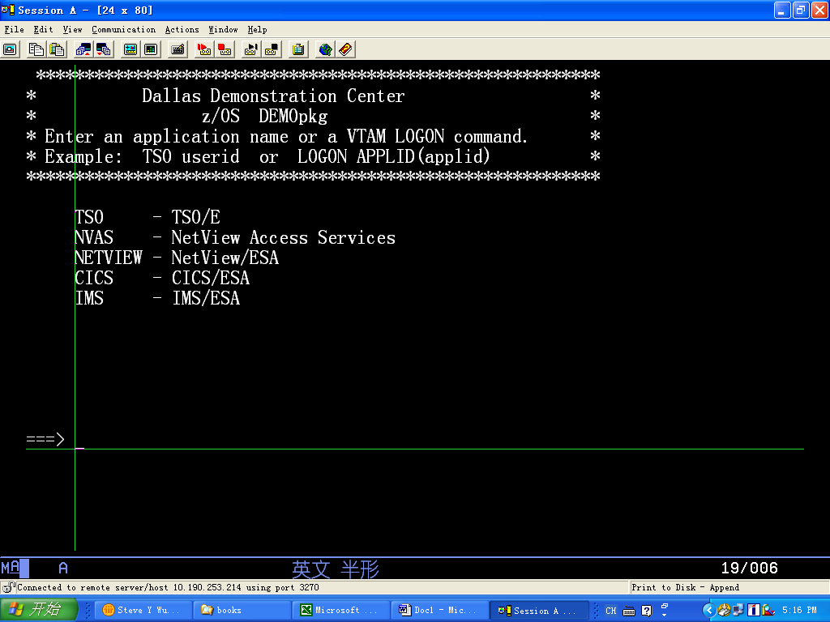

Shutdown the system
Command->Power Off:
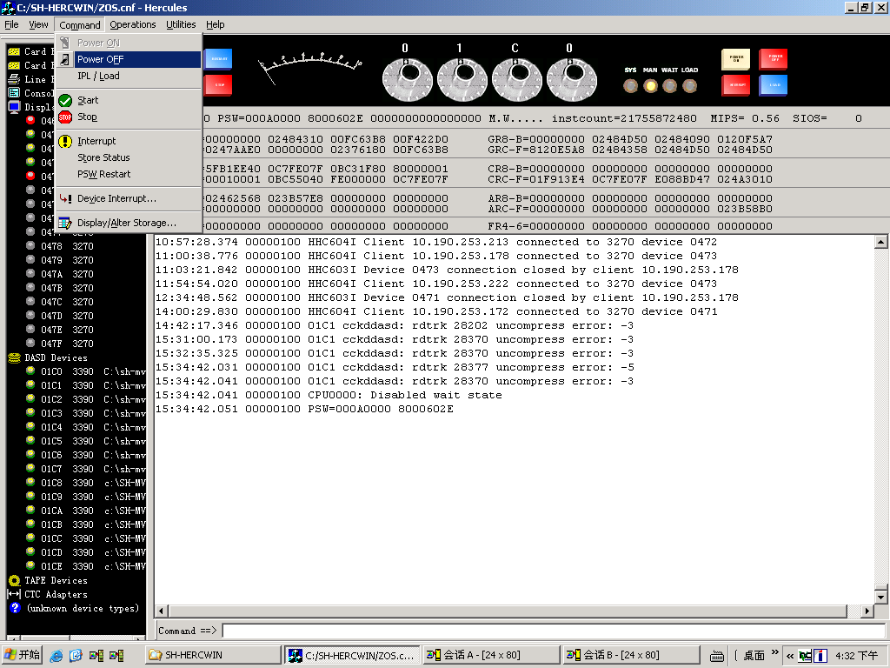
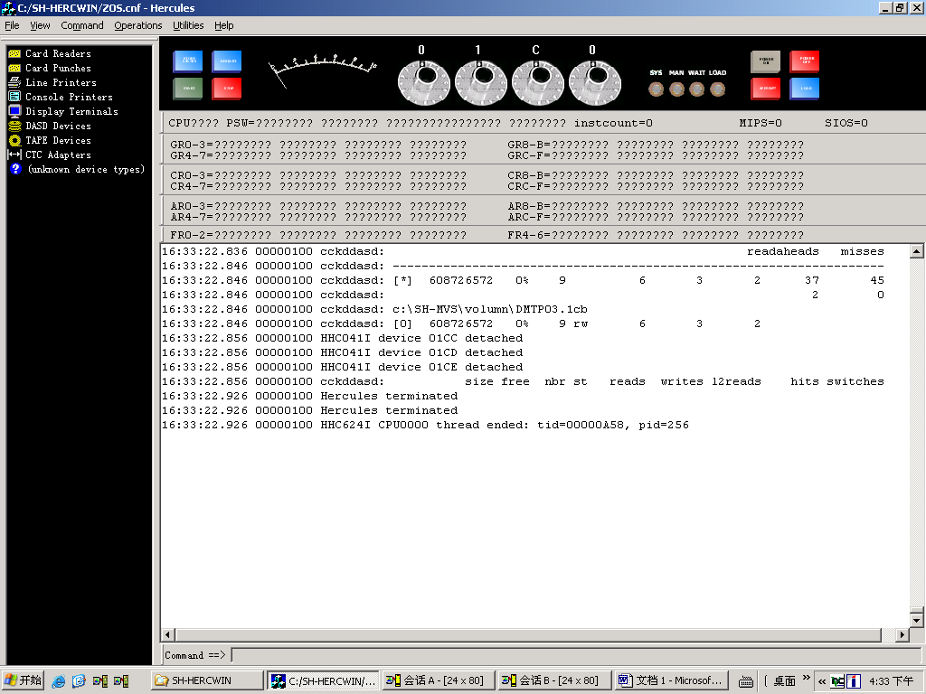

Start the system
Open a PCOM session:
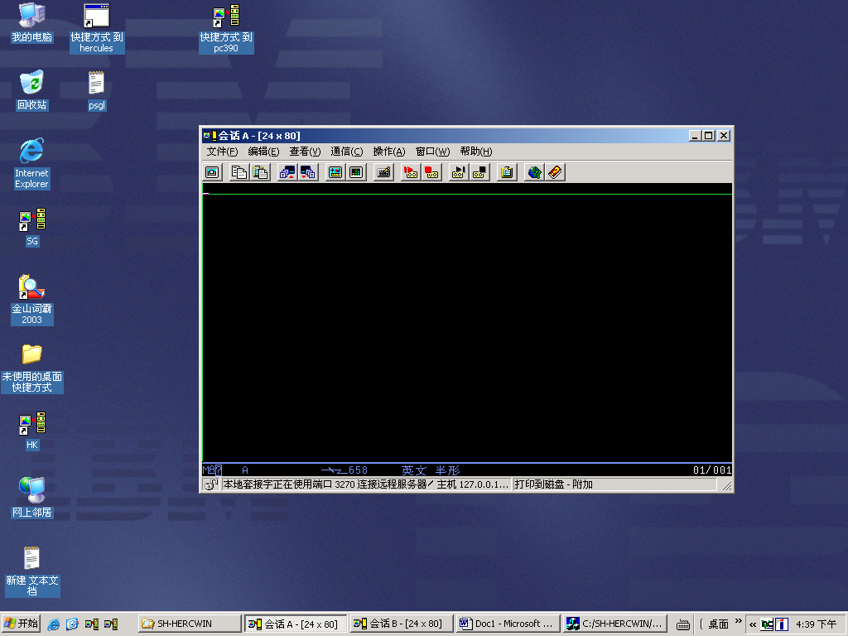
Run E:\MAINFRAME\HERCWIN\HercGui.exe, select File->Preference:
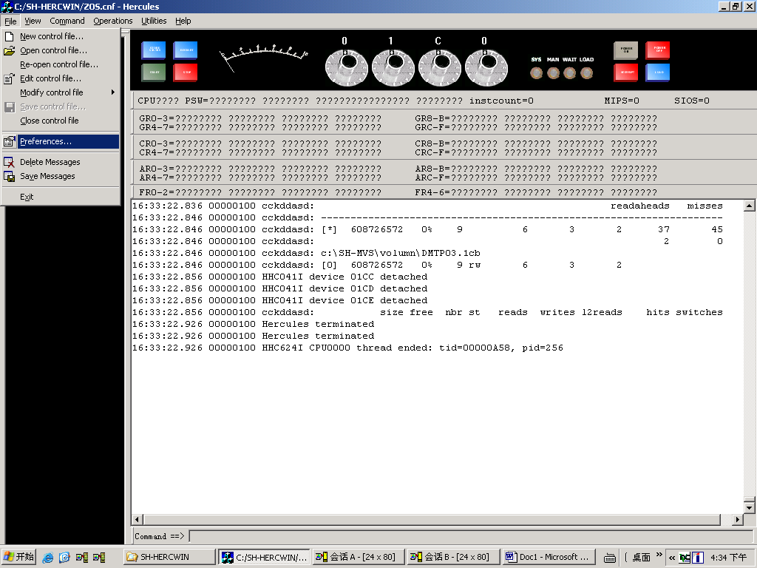
Set below 3 path:
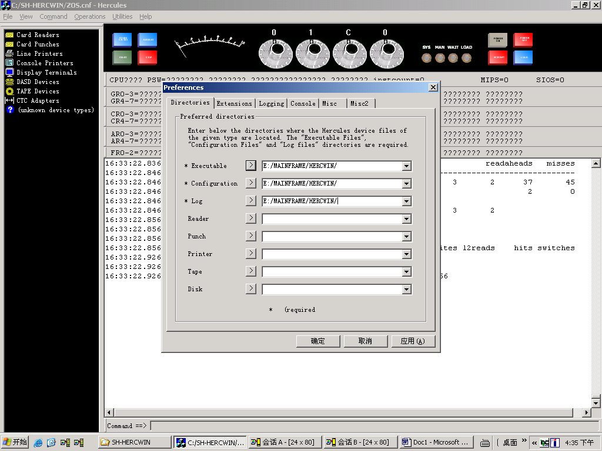
Select config file: File->Open control file:
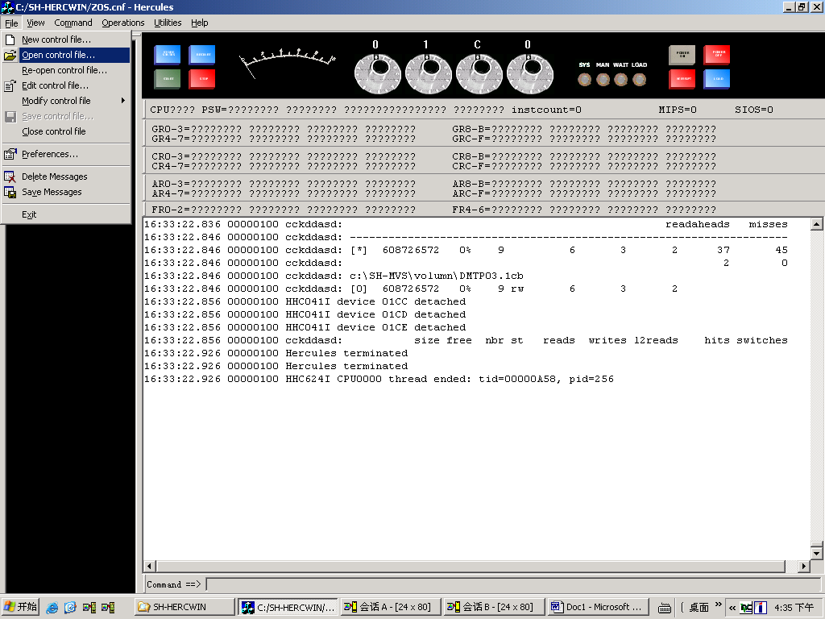
Select ZOS:
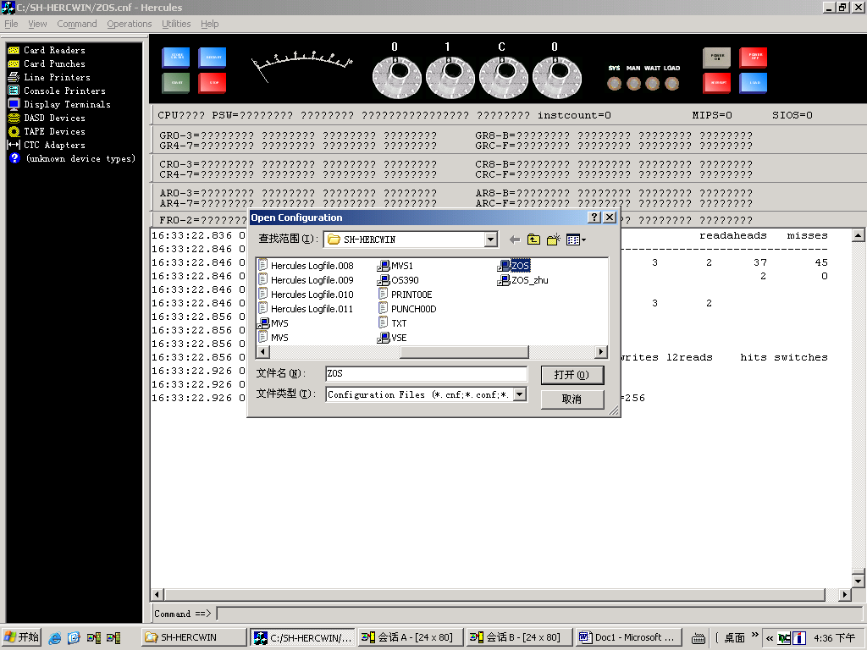
Choose OK:
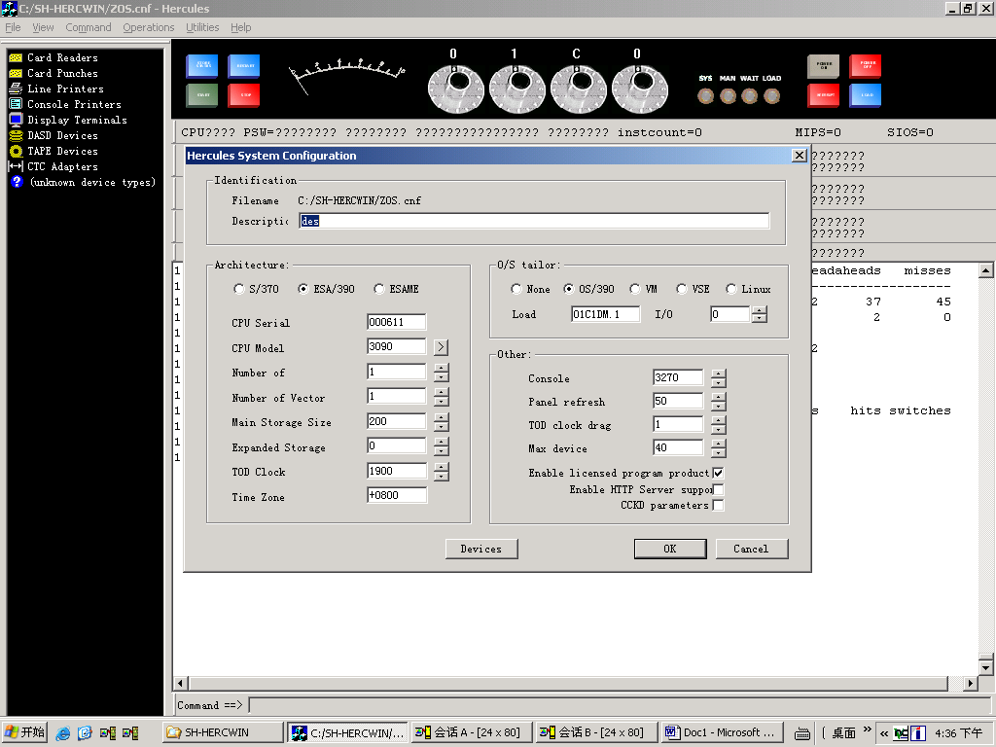
Command->Power On:
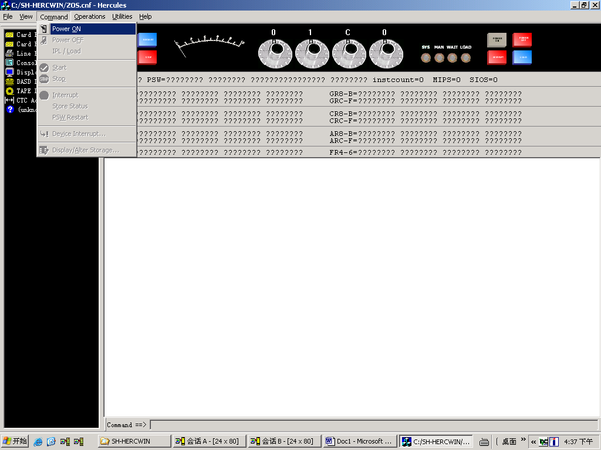
Choose Yes:
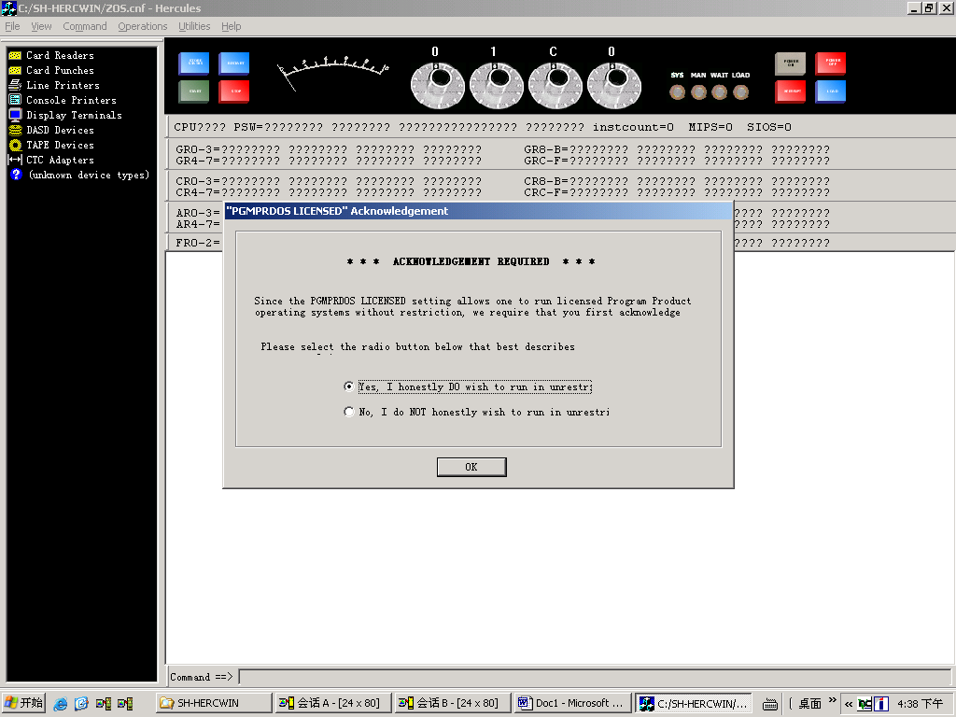
Make sure 0463 is 127.0.0.1:
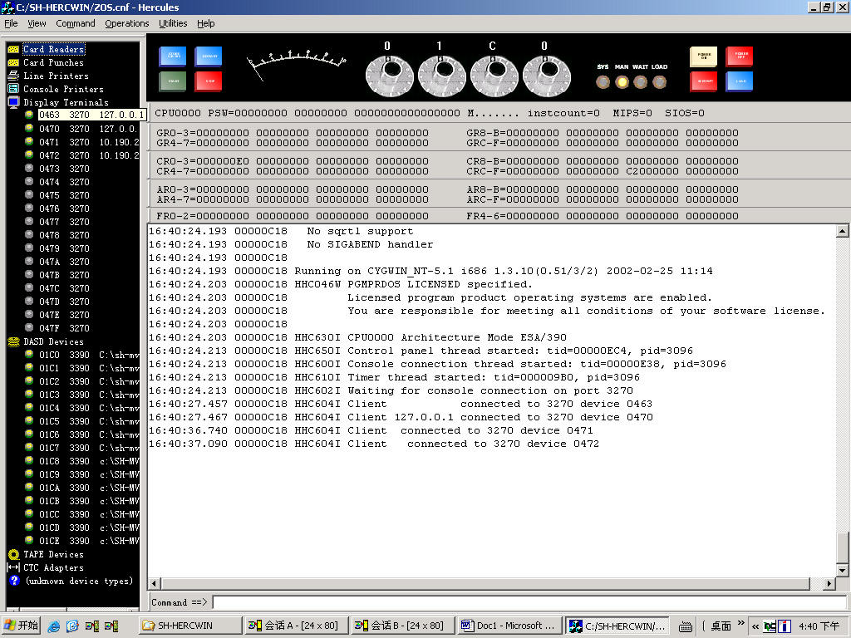
To see PCOM has been connected:
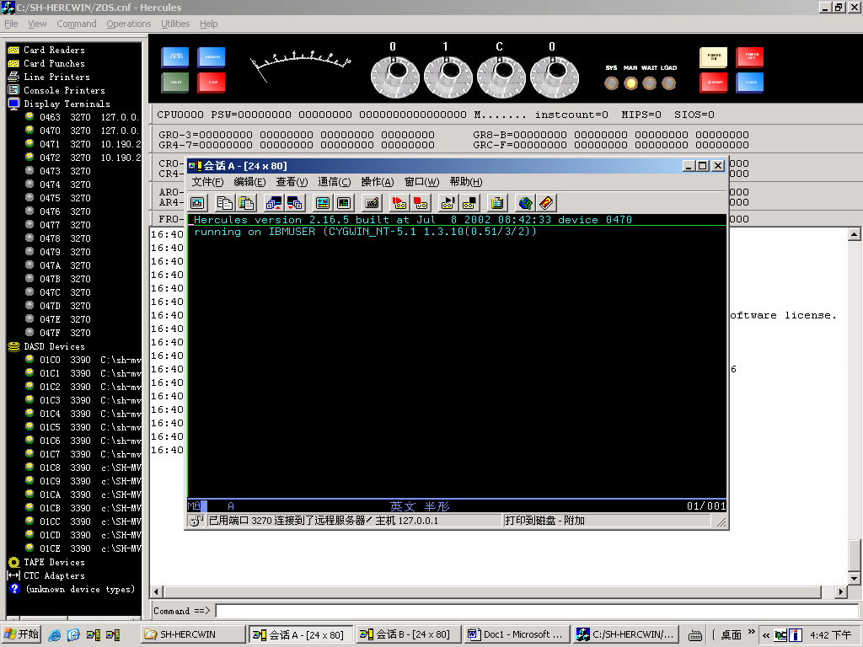
Command->IPL/Load:
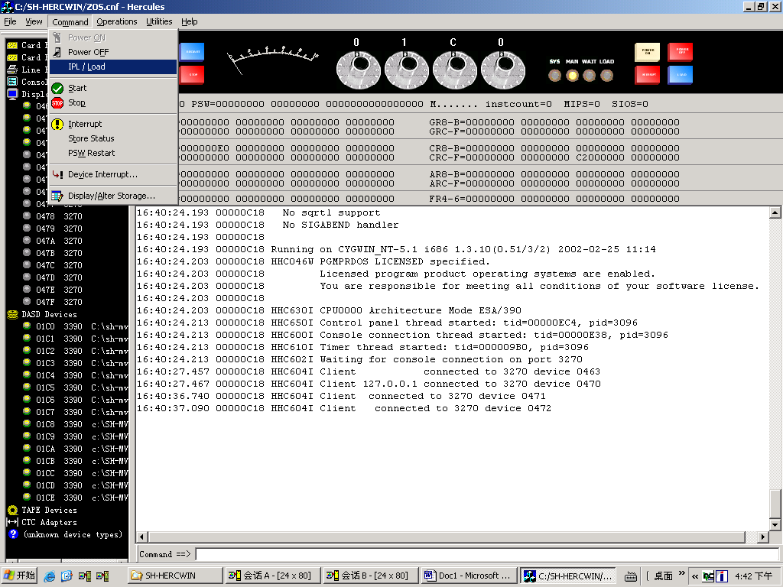
Choose OK:
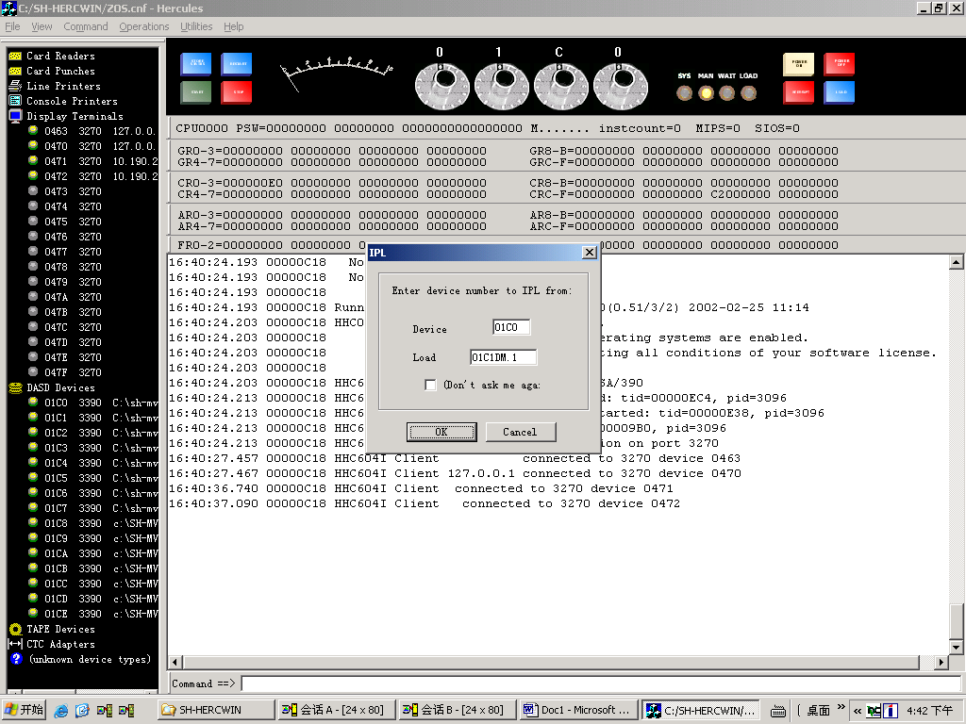
The console show below message:
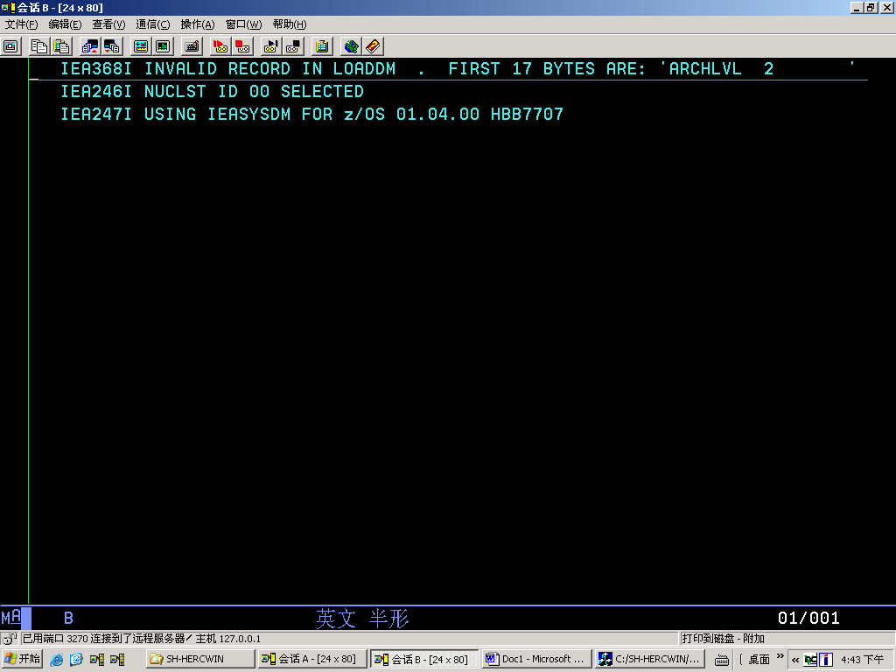
Reply the white message as below:
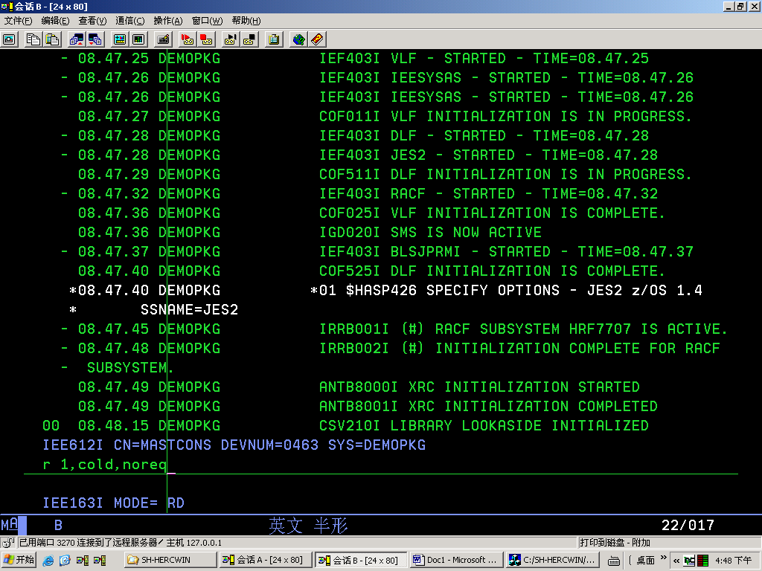
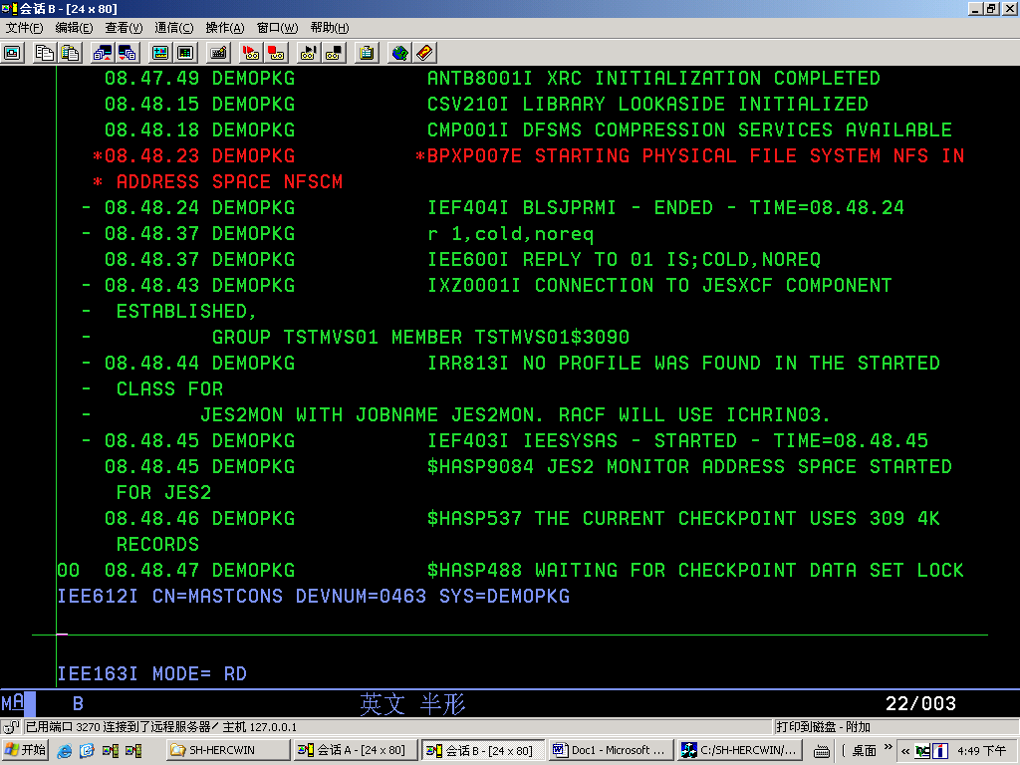
Reply ‘02’ as below:
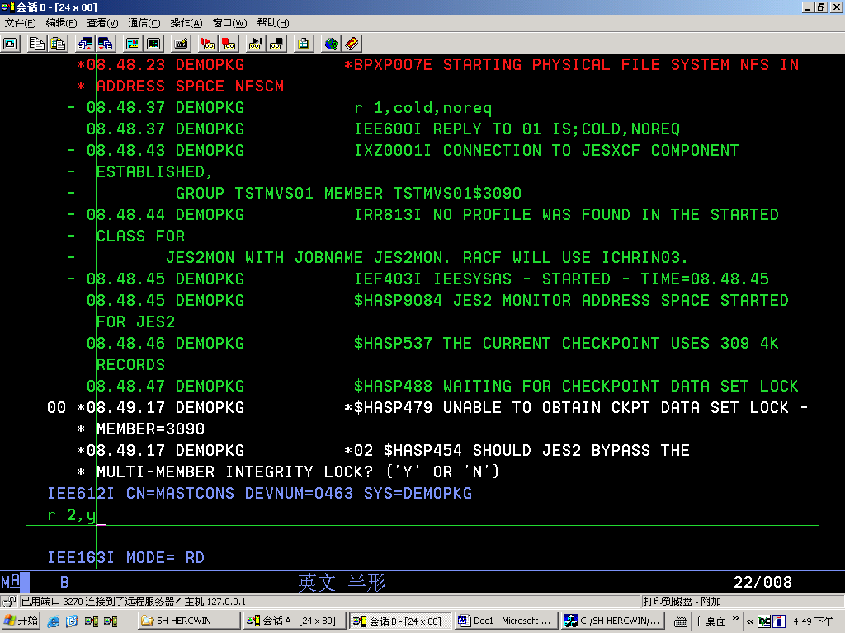
Reply ‘03’ with ‘Y’:
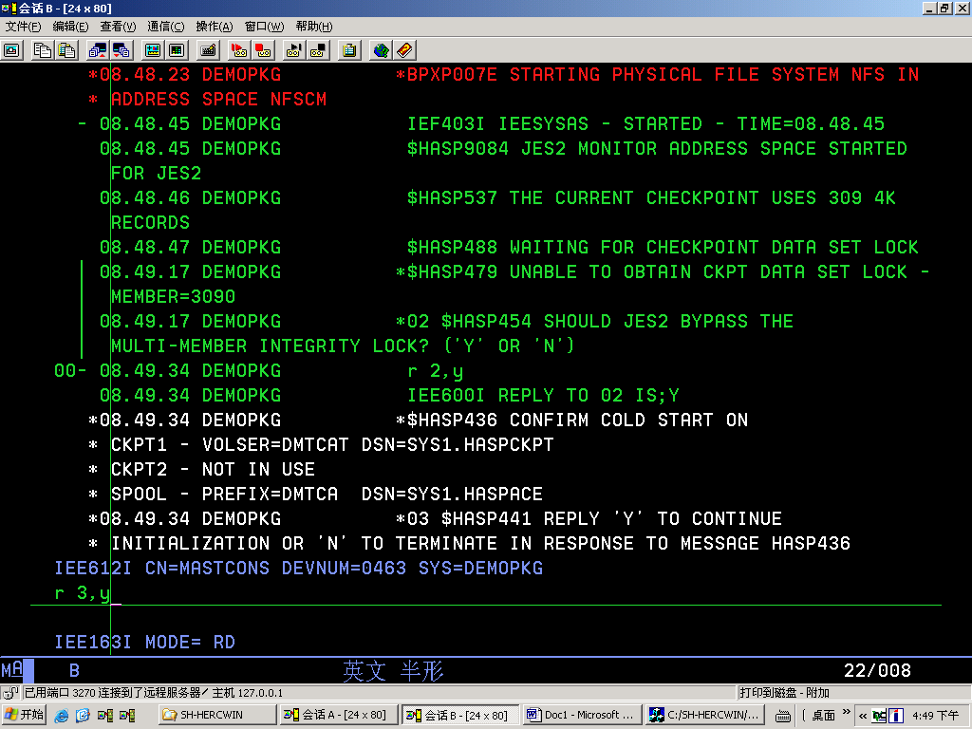
Reply ‘Retry’ as the hint message when it’s needed.

User ID and password:
User ID | Password | Type
EDU000 | EDU000 | Developer
EDU001 | EDU001 | Developer
EDU002 | EDU002 | Developer
EDU003 | EDU003 | Developer
EDU004 | EDU004 | Developer
EDU005 | EDU005 | Developer
EDU006 | EDU006 | Developer
EDU007 | EDU007 | Developer
EDU008 | EDU008 | Developer
EDU009 | EDU009 | Developer
EDU00A | EDU00A | Developer
EDU00B | EDU00B | Developer
EDU00C | EDU00C | Developer
EDU00D | EDU00D | Developer
EDU00E | EDU00E | Developer
EDU00F | EDU00F | Developer
SYSPRG1 | Tjul04g | System Adm

